FPP PB16 Pixel Controller Manual and Assembly Guide

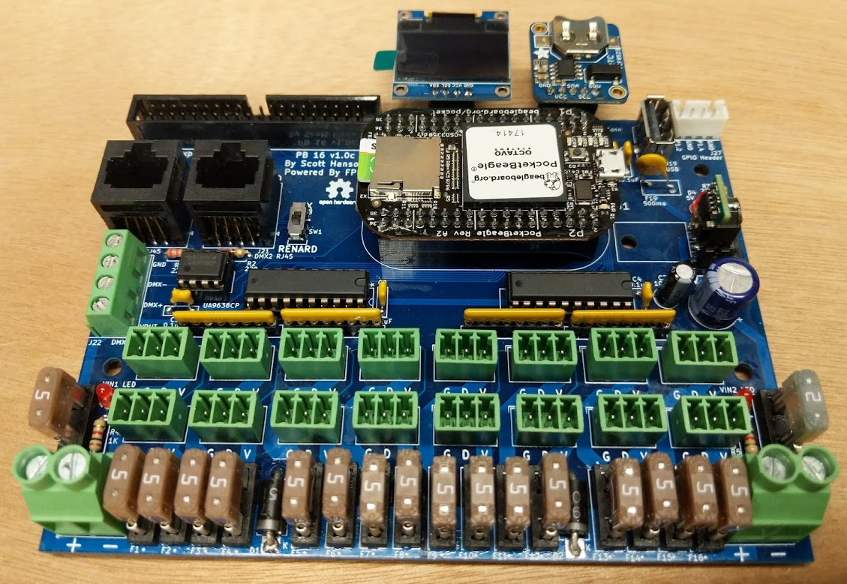

Intro
The PB16 Pixel Controller is designed as an open source DIY hobbyist controller. A Pocketbeagle running FPP drives the 16 pixel ports and 2 serial ports. The design was made with all through hole components for easy assembly by most users. It is designed to be modular and support many use cases. It runs a full Linux operating system with ethernet, WIFI and audio supported over the USB port. It can run in standalone, or be used with other controllers/devices. It is 140mm (5’) wide by 103mm(4’) tall. The controllers small form factor and simplistic design are intended to limit overall cost. All the design files are open source and available on github. Open source applications were used to create this controller. KiCad was used for the PCB design, and LibreOffice for the documentaion.

Features
- Powered by FPP Falcon Player
- Standalone/Master/Remote/Bridge Support
- 16 3-Wire Pixel Ports
- 700 pixel per output at 40 FPS
- 2 DMX Serial Outputs
- 2 RJ-45 Connectors with DMX/LOR/Renard Wiring Support
- Powered DMX Support
- USB port for Ethernet,WIFI, or Audio
- OLED Display header
- Adafruit Real Time Clock Header Connector
- 2 pin GPIO Header for Push Button or Relay Support
- 5v - 24v Vin Support
- 1 Expansion Header for additional 16 pixel outputs

PCB Changlog
rev A - Initial Version. (First Proto PCBs)
rev B - Added Expansion, DMX2 RJ45, and OLED Headers.(never built)
rev C - Added LEDs and GPIO Header. (current testing)
rev D - Added OLED wiring selector switch and AUX power input. Switched to Green LEDs
rev E - Increased AUX power input terminal to 3.81mm
rev F – Added Serial Selector for LOR/DMX, EEPROM, Push Buttons

Hardware Overview
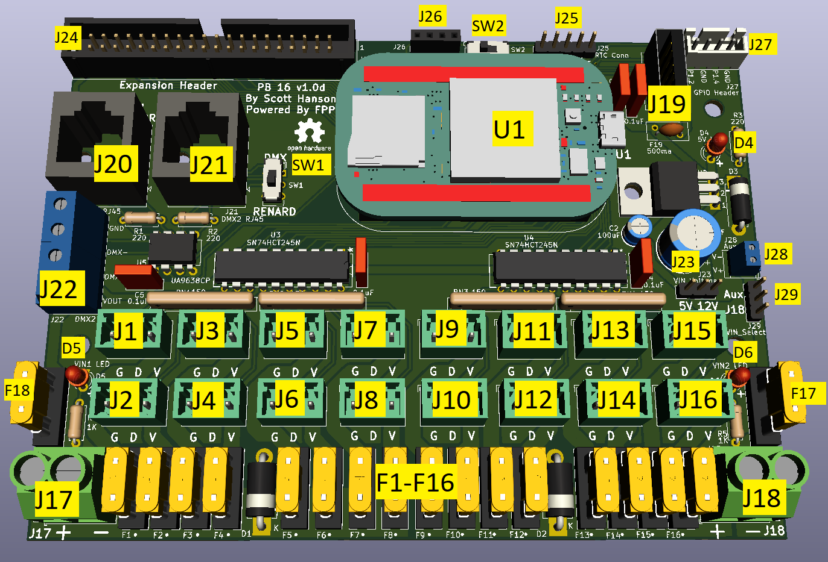

- U1 - PocketBeagle
  - “Brain” of the controller
  - Micro SD Card with FPP software
  - Power LED
  - 4 Activity LEDs
  - Micro USB Port - **WARNING** do not attempt to power PocketBeagle with the Micro USB port and the VIN part at the same time, this will damage it.
  - P1 and P2 GPIO Header
- J1-J16 - Pixel Outputs
- J17 & J18 - VIN1 Left(1-8) and VIN2 Right(9-16) Power Inputs
- J19 - USB Port
- J20 - DMX1 RJ45 Connector with DMX & LOR Pinout
- J21 - DMX 2 RJ45 Connector with DMX or Renard Pinout
- J22 - DMX2 Screw Terminals
- J23 - 5v or 12v Voltage Selector
- J24 - Expansion Header
- J25 - Real Time Clock Header
- J26 - OLED Screen Header
- J27 - GPIO Header (Rev C & up)
- J28 - AUX Power Conn (Rev D & up)
- J29 - Controller Power Selector (Rev D only)
- F1-F16 - 5A Pixel Output Fuses
- F17 - 2A Beaglebone Power Fuse
- F18 - 5A DMX V_Out Fuse
- D4 - 5V LED Indicator (Rev C & up)
- D5 - VIN1 Left Indicator (Rev C & up)
- D6 - VIN2 Right Indicator (Rev C & up)
- SW1 - DMX2 Renard or DMX Selector
- SW2 - OLED VDD/GND Selector (Rev D & up)

Variations
The PB16 Bill of Materials(BOM) spreedsheet contain three variations (sheets across the bottom). The PB16 BOM contains all the parts required to build a complete controller incuding the Real Time Clock and OLED. The PB16 Minimal BOM only has the required parts to create a 16 output pixel controller. It omits the serial hardware, additional headers, sockets for IC’s, OLED, RTC, and indicator LED’s. The PB16 Power Inject BOM includes the serial, additional headers, and OLED hardware, but omits the fused outputs. The pixel ouputs are only two pin terminal with data and ground. Full BOM on Digikey

Power
The PB16 controller has two main power inputs J17 and J18. J17 powers the pixels outputs 1-8 an the DMX out. J18 powers pixels outputs 9-16 and the controller itself. Each input are separate and can run the same or different voltage pixels. To power the controller off J18, set the J29 jumper to the lower two pins. If using 5V pixels on J18, set the J23 jumper to the 5V(left two pins). If using 12v or 24v pixels set the jumper to the 12v(right two pins). To power the controller off an external supply set the J29 jumper to the upper two pins and attack 5 or 12v to J28.

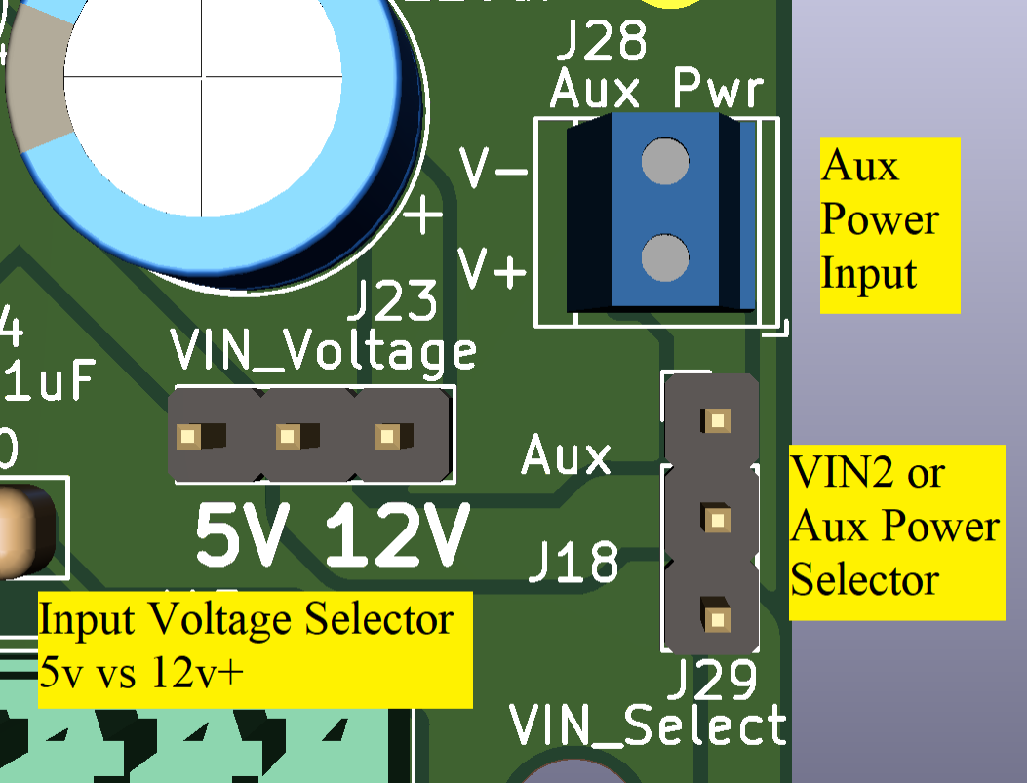
Pixel Outputs
The PB16 controller has 16 one-wire ws2811 pixel outputs. Each output can run 700 pixels at 40 fps and 1400 pixels at 20 fps(with power injection). The expansion header can drive an additional 16 pixel outputs through an expansion board.
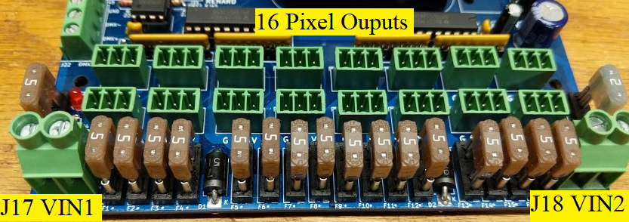

Serial Outputs
The PB16 controller has two serial outputs. The first serial output is wired to DMX1 RJ45 connector. The DMX1 RJ45 connector is wired for both standard DMX pinout(pins 1& 2) and the LOR DMX pinout(pins 4 & 5). The second serial output is wired to DMX2 RJ45 connector and DMX2 4-pin screw terminal. Both connects are wired to the same serial output, and cannot be used separately. DMX2 RJ45 connector has a slider switch to select DMX pinout(1&2) or Renard Pinout(5&4). The controller does not support the renard protocol, only renard controllers with the DMX firmware will work. DMX2 4-pin screw terminal provides a DMX+ and DMX- breakout for custom DMX wiring. The VOUT pin provides a fused voltage output for low powered DMX devices like flood lights. This voltage is the same as J17 VIN1.
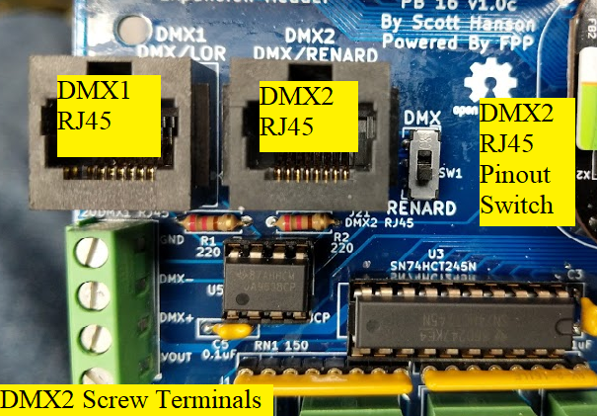

USB & GPIO
The PB16 has a USB port for a USB to Ethernet/Wifi adapter. The USB port can also be used with a USB Audio Adapter. The USB port by default only supports unpowered USB devices. If you want to use a self powered USB device, remove F19. The USB port has minimal hardware and overcurrent protection. Only use certified USB devices to revent damage. Do not use the USB port to power high current devices like Raspberry Pi’s or a cell phone. The GPIO header allows the controller to drive external hardware like Relay boards or be used as switch inputs to trigger FPP events.

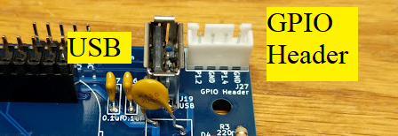
Expansion Header
The PB16 controller has an expansion header that allows it to drive 16 additional pixel outputs. The header pinout is compatible with F16V3 Expansion Boards.

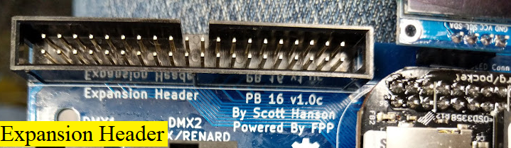
OLED
The OLED displays the FPP player status, Host name, and IP address. The OLED screen must be enabled in the FPP settings.
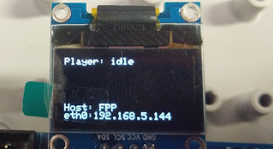

Assembly
Note: The Pictures are of a Rev C PCB but the instructions include the Rev D changes.

- Install Resistors and 0.1uF Capacitors..
  - Install three(3) 200ohms resistors, R1, R2, R3 (Red)
  - Install two(2) 1K resistors, R4, R5 (Orange)
  - Install five(5) 0.1uF capacitors, C3, C4, C5, C6, C7 (Yellow)
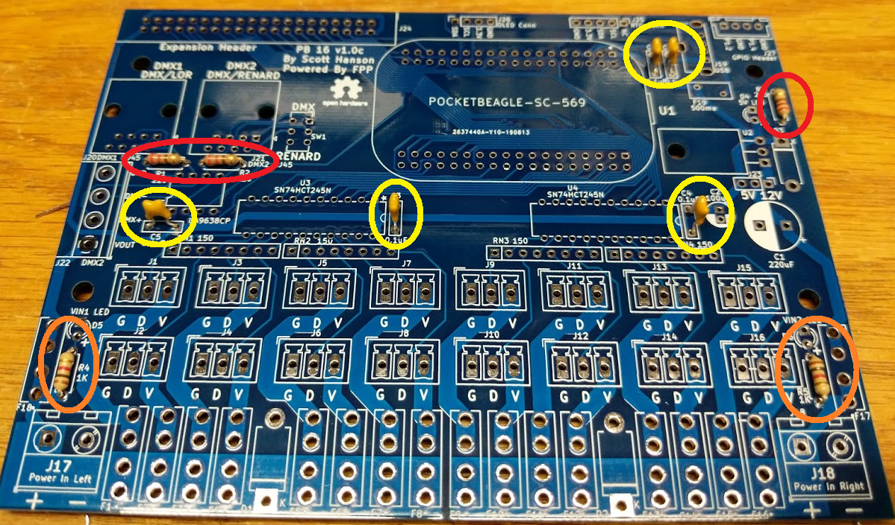

- Install LEDs and Diodes.
  - Install three(3) Red or Green LED’s, D3, D4, D5. Long leg must be placed in positive(+) hole. (Red)
  - Install one(1) “1N5338” 5.1V zener diode, D3, White line must be placed towards “K”. (Green)
  - Install two(2) “SB5100” schottky diodes, D1, D2, White line must be placed towards “K”.
(Yellow)
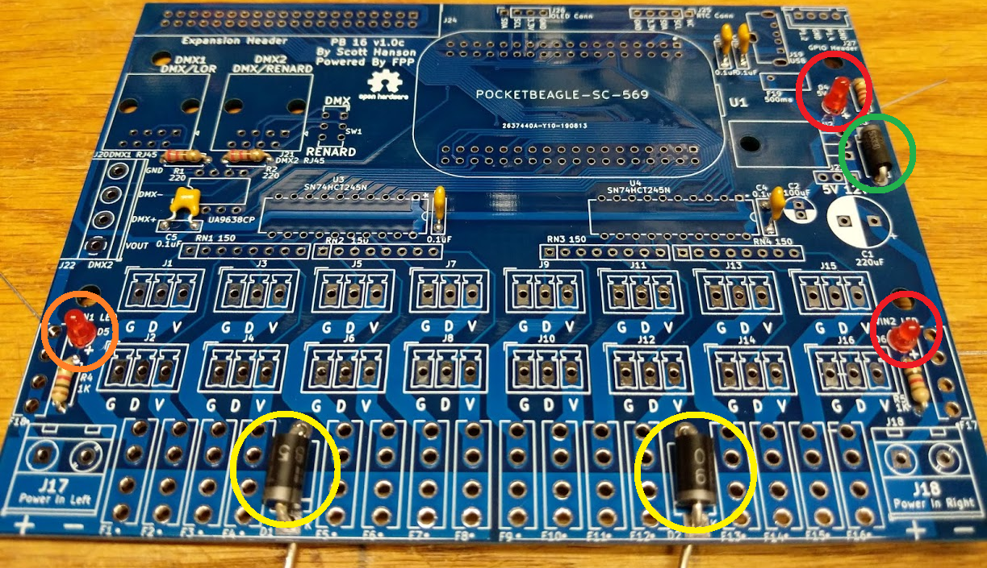

- Install the DIP and SIP Sockets.
  - Install two(2) 20 pin Dual Wipe DIP Sockets at U3, U4. Notch should match half circle on silkscreen. (Orange)
  - Install one(1) 8 pin Dual Wipe DIP Sockets at U5. Notch should match half circle on silkscreen. (Green)
  - Install four(4) 8 pin SIP Sockets at RN1 - RN4. (Red)
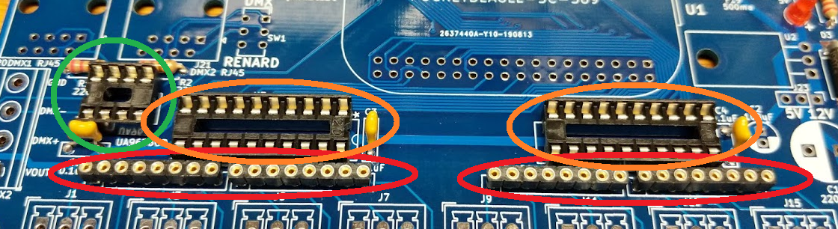

- Install Switches.
  - Install two(2) slide DPDT switches, SW1, SW2.(Red)
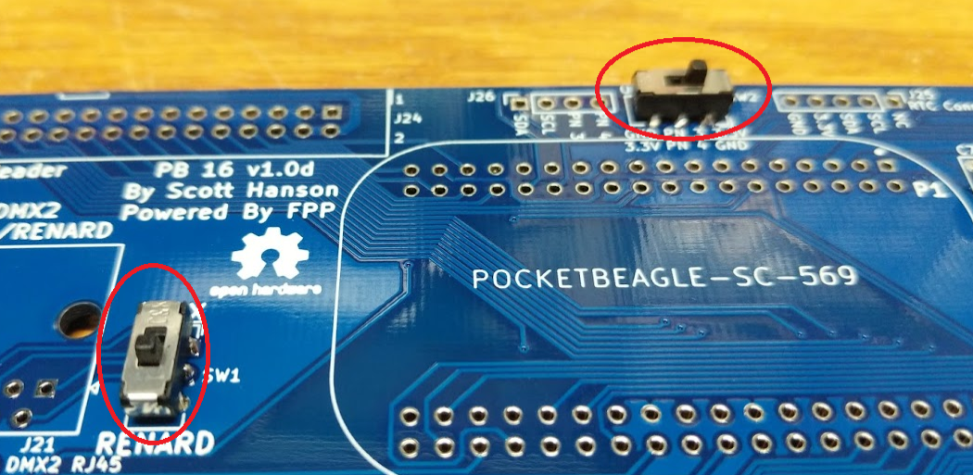
- Install Header Pins.
  - Install two(2) 3 pin headers at J23, J29. (Red)
  - Install one(1) 5 pin header at J25. (Green)
  - Install one(1) 4 pin JST header at J27. (Yellow)
  - Install one(1) 40 pin header at J24. Notch must point upward, toward the top edge of the PCB. (Orange)
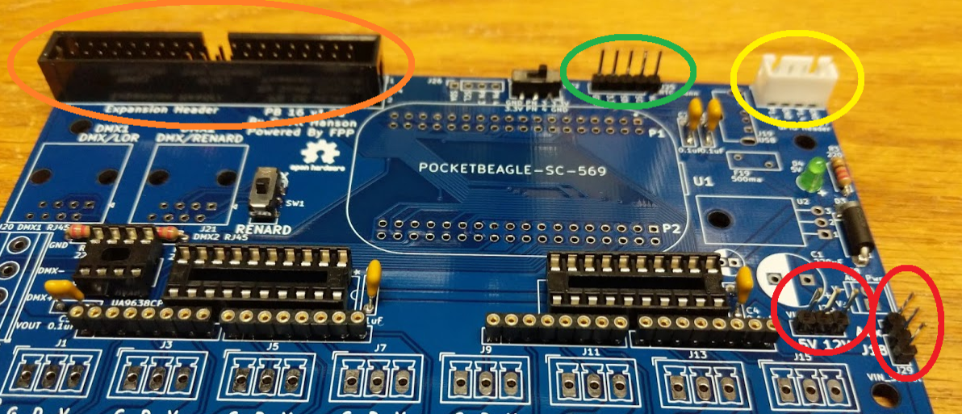
- Install Fuse Holders.
  - Install eighteen (18) Mini blade fuse holders at F1 - F18. (Red)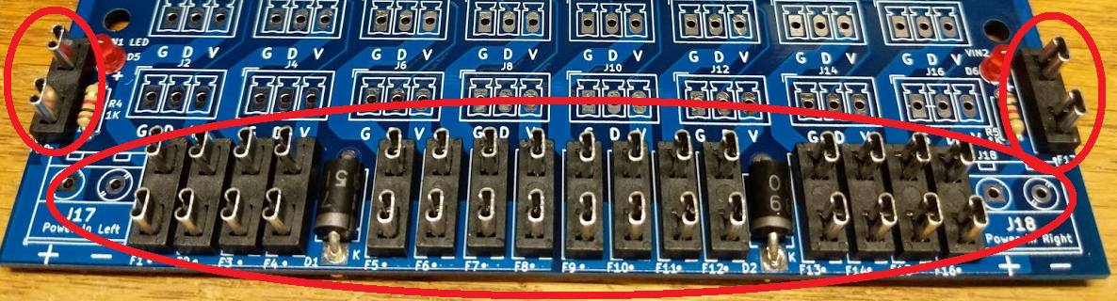
- Install String Port Headers.
  - Install sixteen(16) 3 pin headers at J1 - J16. Triangle Notches Face Upward. (Red)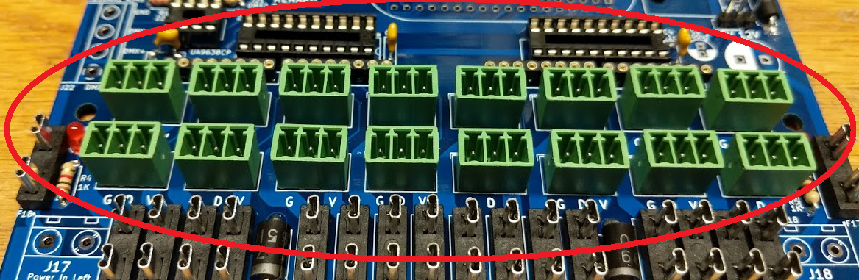
- Install Header Sockets.
  - Install one(1) 4 pin header socket at J26.(Red)
  - Install two(2) 36 pin header sockets at U1.P1 and U1.P2 (Yellow)
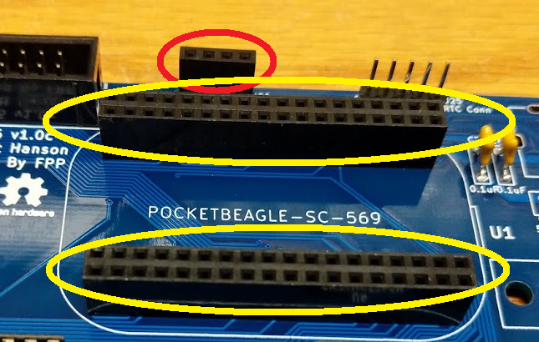
- Install Small Screw Terminals.
  - Install one(1) 2 pin screw terminal at J28. Wire terminals must face edge of PCB. (Yellow) (J28 not present on rev C PCB’s)
  - Install one(1) 4 pin screw terminal at J22. Wire terminals must face edge of PCB. (Red)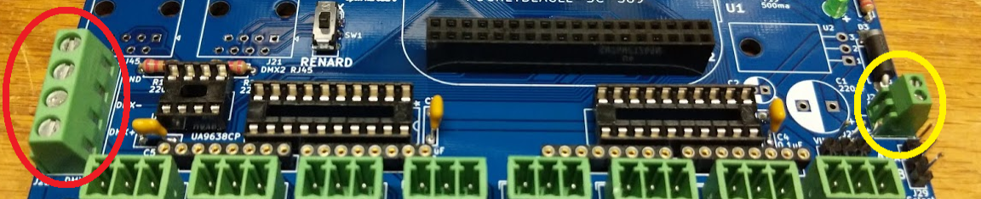
- Install Large Capacitors and PTC Fuse.
  - Install one(1) PTC Fuse at F19. (Red)
  - Install one(1) 100uF Capacitor at C2. White Line should match white half circle on PCB silkscreen. (Orange)
  - Install one(1) 220uF Capacitor at C1. White Line should match white half circle on PCB silkscreen. (Yellow)
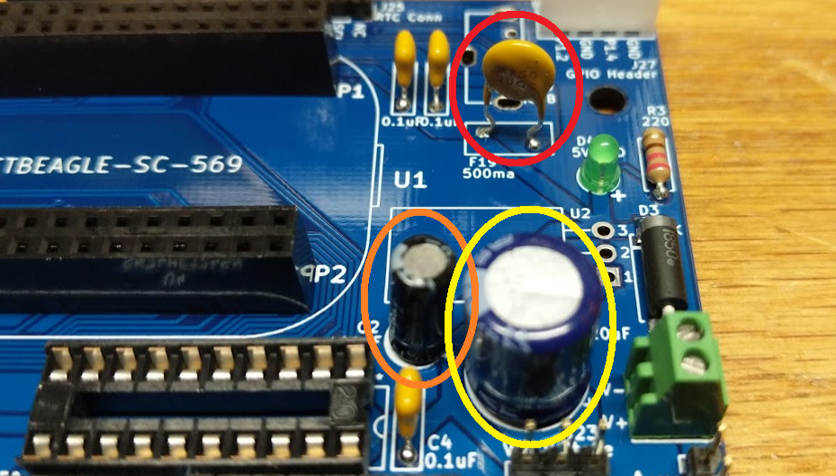
- Install USB Port.
  - Install one(1) Vertical USB A Port at J19. (Red)
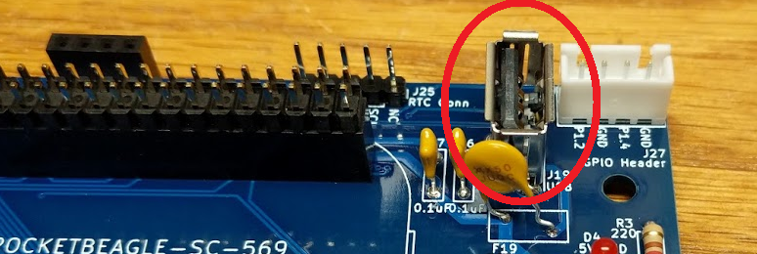

- Install Voltage Regulator
  - Install one(1) 5V DC to DC Regulator at U2. Pin 1 should point downward. (Red)
    - Big circle inductor and label should face edge of PCB.
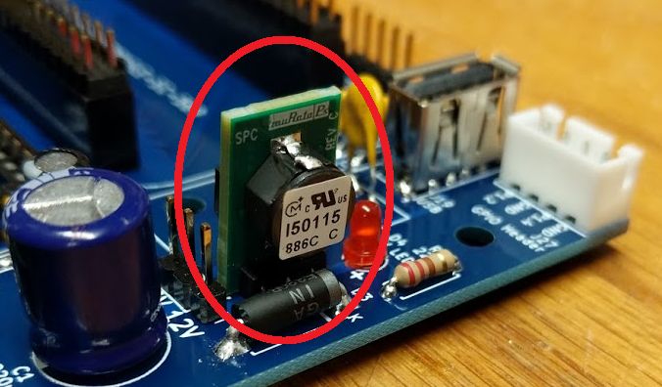

- Install RJ45 Ports.
  - Install two(2) 8 pin RJ45 header sockets at J20, J21. (Red)
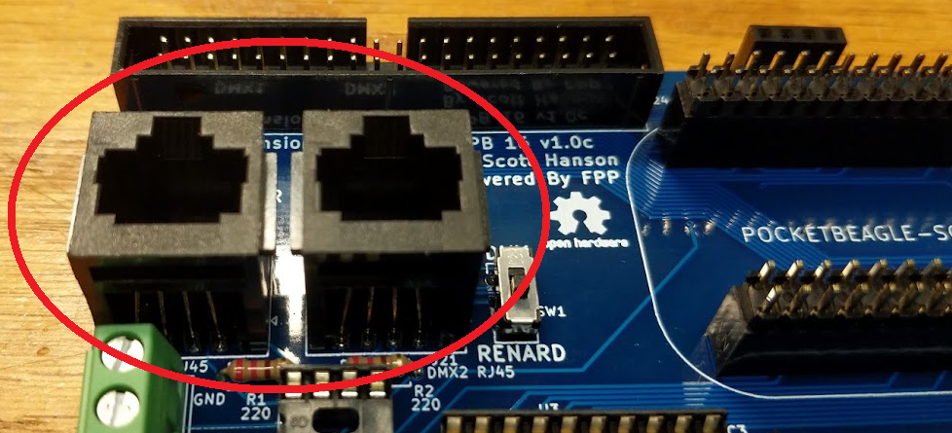
- Install Power Screw Headers.
  - Install two(2) 2 pin screw terminals at J17, J18. Wire terminals must face edge of PCB. (Red)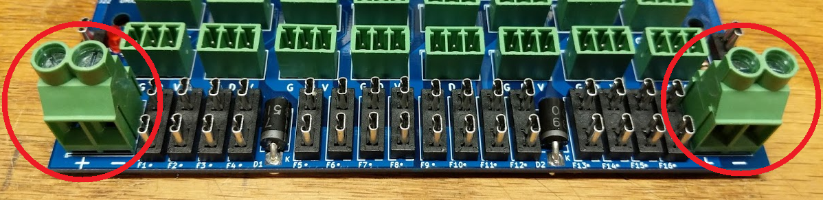
- Test Power
  - Install one(1) 2 amp Mini Fuse at F17
  - Install power jumper on J29’s lower two pins.
  - Install power jumper on J23 for the desired input voltage. (5
  - Apply power to the board at selected voltage.
  - VIN2 and 5V LED’s should illuminate.
  - Measure U2 Pin 3 or F19 Left Pin for 5 volts.
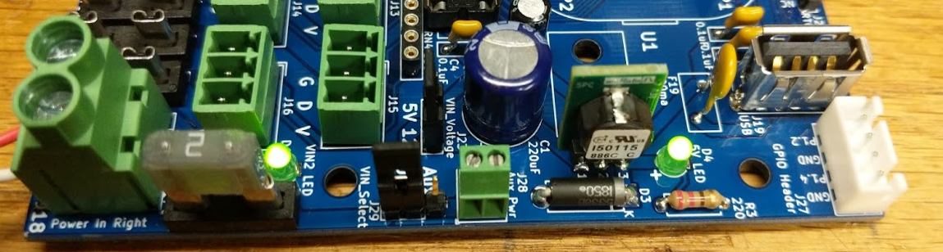
- Insert IC Chips and Resistor Packs.
  - Install two(2) 74HCT245N 20 pin IC at U3, U4. Notch or Dot should match the socket notch. (Red)
  - Install one(1) UA9638CP 8 Pin IC at U5. Notch or Dot should match the socket notch. (Yellow)
  - Install four(4) 8 pin 150ohm resistor packs at RN1-RN4. (Purple)
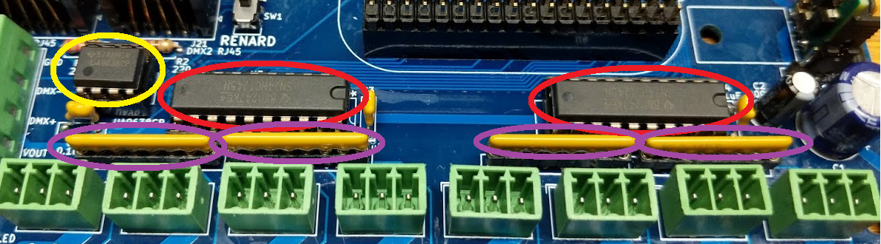
- Install Pocket Beagle.
  - Install two(2) 36 pin pin headers into the PCBs U1.P1 and U1.P2 pin sockets. (Red)
  - Place Pocket Beagle on dual 36 pin headers, SD slot/ Micro needs to be face up. SD slot should point towards RJ45 connectors. Solder headers to Pocket Beagle.
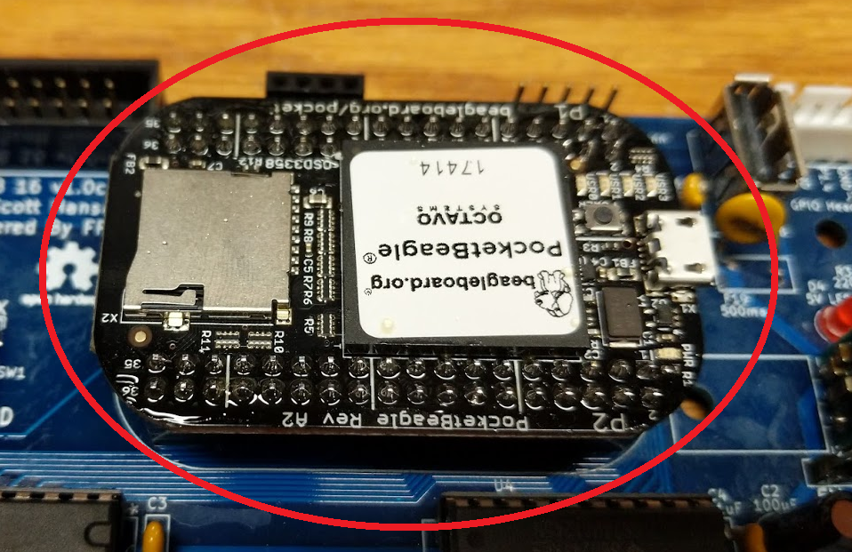
- Insert Fuses.
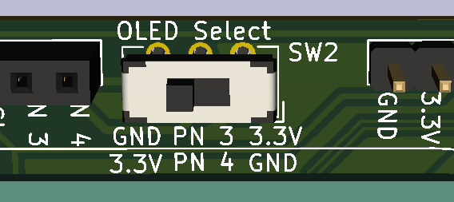
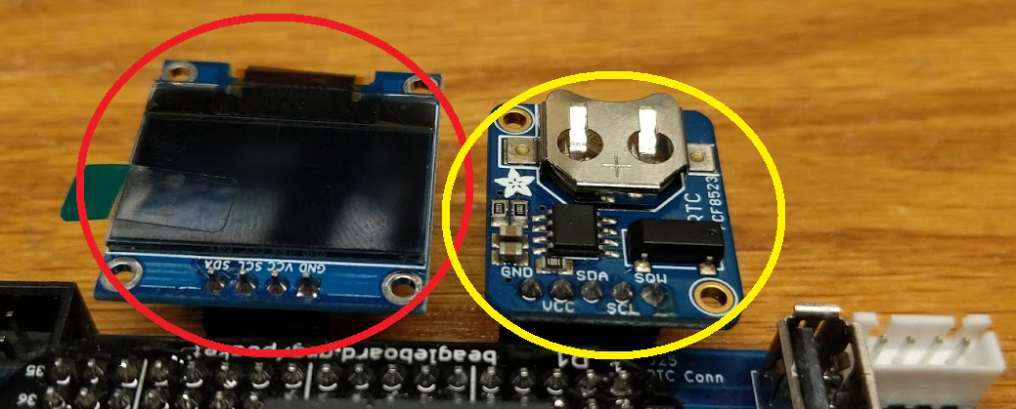
  - Install seventeen(17) 5 amp Mini Fuses at F1-F16, F18. (Red)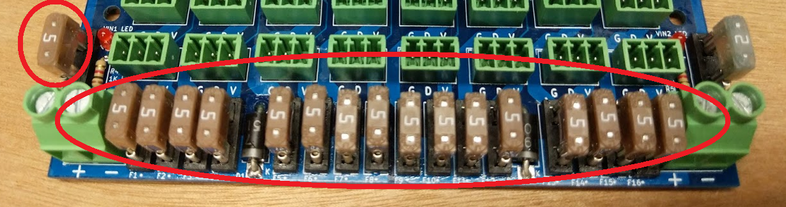
- Optional Components
  - Install Adafruit RTC on J25. Mount hole should be to left of the header and battery upward. (Yellow)
  - Install OLED Display at J23 (Red)
    - Slide SW2 Left if Pin 3 is GND and Pin 4 is 3.3V on OLED Pinout. (Rev D PCB only)
    - Slide SW2 Right if Pin 3 is 3.3V and Pin 4 is GND on OLED Pinout.

- Software Setup
  - With the Controller Off.
  - Plug in USB to Ethernet or Wifi Adapter.
  - Insert Micro SD Card with FPP 3.1 or newer image.
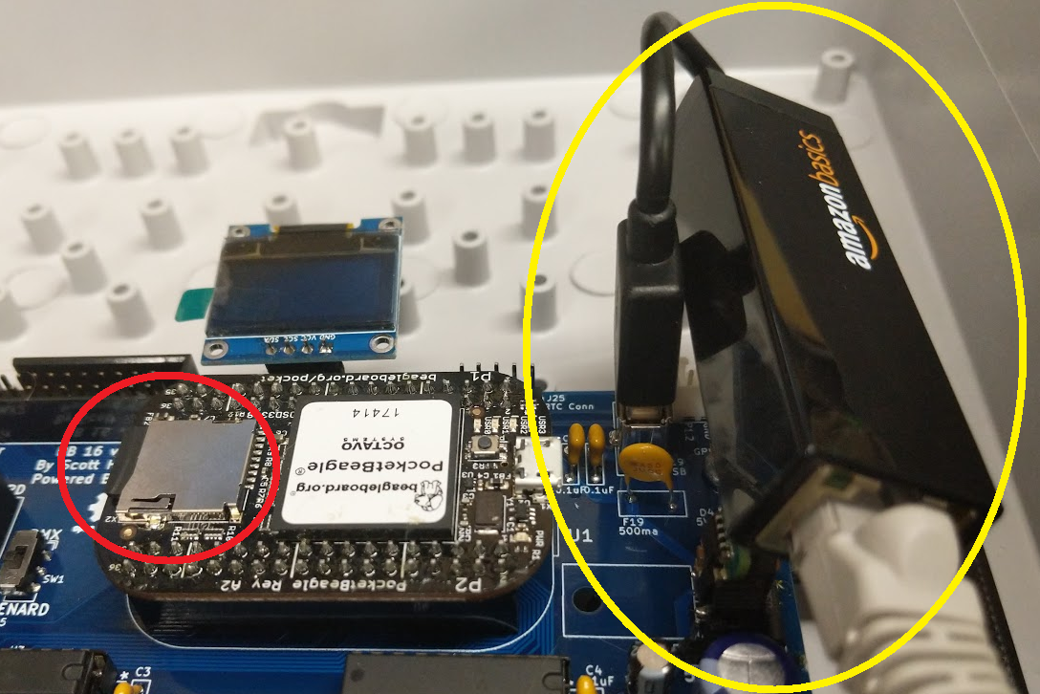
  - Power On Controller.
    - The OLED will not display anything on first boot.
    - Pocketbeagle Status LED should elluminate.
  - Open the FPP Web Page.
  - Enable OLED in the FPP Setting Menu.
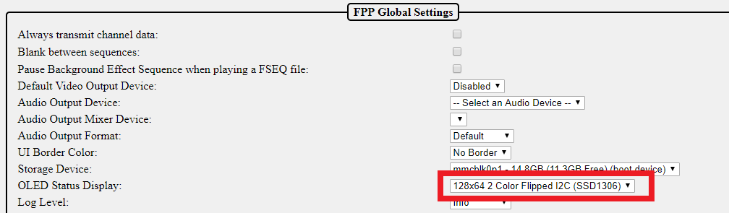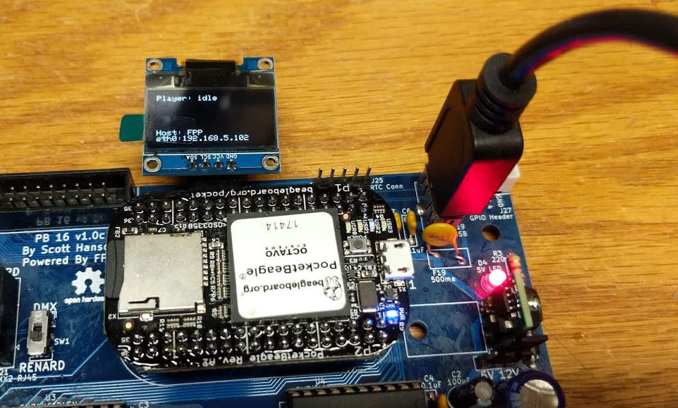
  - Upload the ‘PB16-eeprom.bin’ file on the Uploads File Manager Screen.
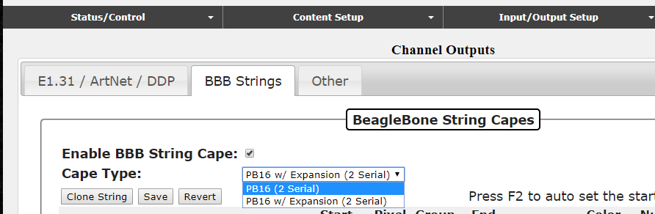
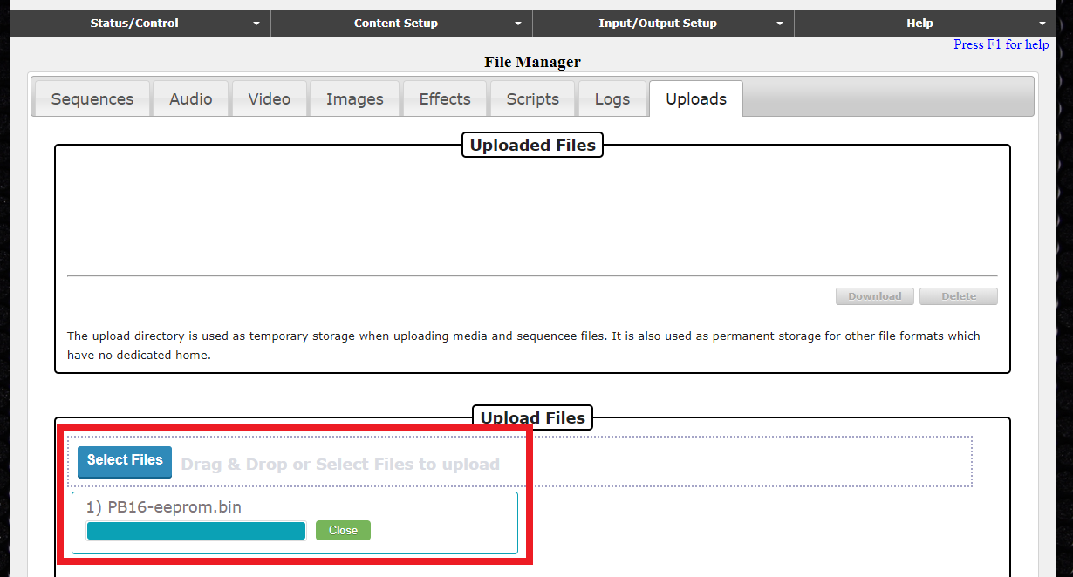
  - Then Reboot
  - The PB16 Cape Type should appear in the BBB Strings Output page now.
  - The Help About Page should also display the Cape information.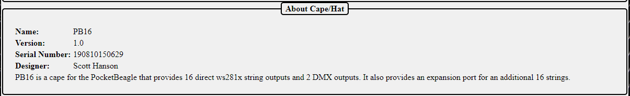
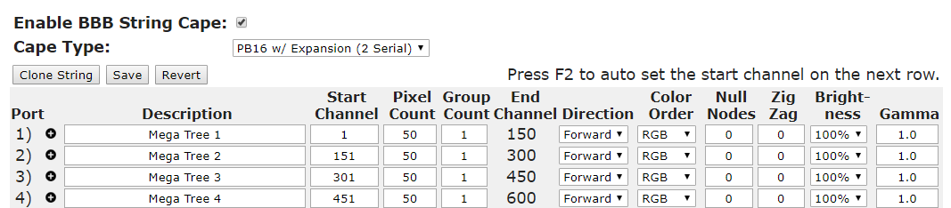
  - Setup the String Output Data.
  - Profit!

